Pessary-Diaphragm Guide

Pessary-Diaphragm Ordering and Tracking

Pessary Ordering Documentation

During a diaphragm fitting or pessary fitting, check, or resizing, it is important to utilize the WHA OB/GYN Procedure Note template. This template includes a procedure SmartBlock and automatically assigns the appropriate CPT code as the form is completed.

! IMPORTANT: If a patient is seen for a problem visit and a fitting is performed during the same encounter, make sure that you or the clinician include the smartphrase ".procdoc" so that the Procedure SmartBlock is inserted into the existing note template.

- Access the Procedure SmartBlock within the note template.
- Search for "Pessary, Fit/Insert." and complete the procedure form.
- The clinician should select the appropriate Pessary procedure type, such as fitting, insertion, resizing, or cleaning/check.
  - This selection will ensure the correct procedure charge is applied.
  - The appropriate E/M code can then be added to the LOS as needed.
- Select the Pessary type and size.
- New pessary dispensed to patient: non-rubber.
  - Selecting this option will drop a charge for the pessary.
  - For the pessary to be considered new, it must be fitted/refitted for the patient, which involves the physician measuring/re-measuring the patient and providing appropriate fitting of the new pessary.
  - Please DO NOT select an option in this section if you need to order a pessary for the patient. You or your MA/LPN will add the pessary charge once the pessary has been received and the patient has either picked it up from the office or it has been placed during their next scheduled appointment.

If pessary is in stock:

- Clinician places charge for pessary using the procedure SmartBlock.
- MA to get pessary from stock, place pessary information on re-order sheet for the weekly purchasing order.
- MA/LPN is responsible for retrieving pessaries from inventory and documenting the pessary details on the reorder sheet. The designated Purchasing Team member for your site will review the order sheet and place orders on a weekly basis.
  - Please note that purchase ordering timelines may vary per site.

If Diaphragm is in stock:

- Charge capture is required when a diaphragm is dispensed to ensure proper reimbursement.
- This should be completed by the clinician at the time of the visit, but only if the diaphragm is dispensed during that visit.
- In the chart, go to “This Visit” → “Charge Capture” and enter code A4266.
- Providers must also submit a prescription for a water-based contraceptive gel (Caya recommends VCF gel as an example) to the patient’s pharmacy of choice.
- Diaphragm Inventory and Storage
  - OC will maintain a limited number (3-4) in stock
  - PKN will maintain a limited stock for the West Hub.
- For BR and HB Sites
  - For the above West hubs, if a diaphragm is needed, patients may stop by PKN to pick one up, or staff can coordinate with a supervisor to have one sent via interoffice mail.
  - See site supervisor for storage location.

If diaphragm needs to be picked up at another site or ordered:

- Provider to document in progress note or assessment & plan that Caya diaphragm needs to be ordered or picked up at a different location.
- MA/LPN to place diaphragm information on re-order sheet for the weekly purchasing order when removing one from stock.
- MA/LPN will create a phone encounter and add details or use a smartphrase (WHAPHONEDIAPHRAGMPICKUPORDER)and route it to the pod pool until diaphragm is received.
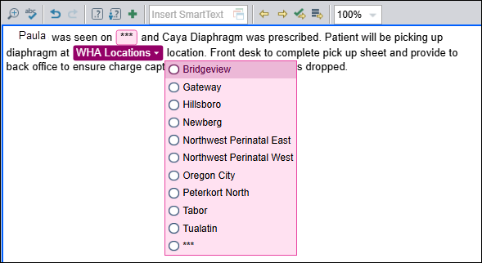
- Once the patient picks up the diaphragm, the Patient Services team member should complete the half sheet and update the phone note to include the pickup date and route the phone encounter to the appropriate Pod Pool.
- Support staff need to update the note stating charges were placed in this telephone encounter before signing.
- Navigate to the Charge Capture tab:
  - Add code for Diaphragm (A4266).

If pessary needs to be ordered:

- Provider to document in progress note or assessment & plan what pessary needs to be ordered.
- MA/LPN to place pessary information on re-order sheet for the weekly purchasing order.
  - If your provider requires a specific type of pessary, the MA/LPN should send a message to their supervisor with pessary information – such as type, size, patient information, provider, etc.

- MA/LPN will create a phone encounter and add details or use a smartphrase (WHAPHONEPESSARYORDER)and route it to the pod pool until pessary is received.
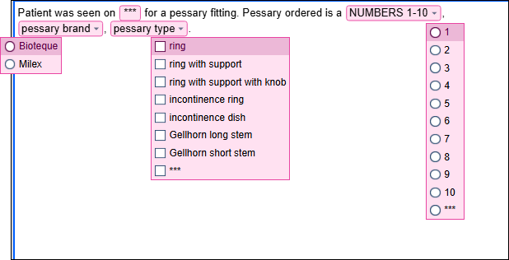
- Once the pessary is received, a patient label will be applied to pessary along with the Pessary pick-up Info Sheet and should be placed in the designated location determined by your site.
- MA/LPN will update the phone note accordingly using a SmartPhrase (.WHAPHONEPESSARYRECEIVED)and route to your patient services pool to document the next steps.
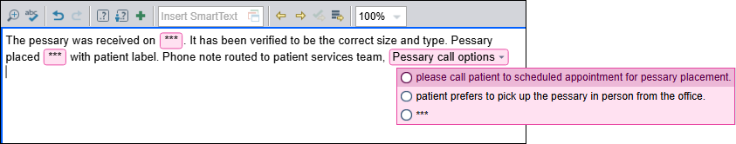
- If a patient requires an appointment to have their pessary placed, update the phone note accordingly. Initiate a warm handoff or route the phone encounter to Patient Services pool to schedule the appointment. Charges will be applied at the time of the appointment.
- If the patient plans to pick up the pessary at the front desk, update the phone note accordingly and route the phone encounter to the Patient Services pool.
- Once the patient picks up the pessary, the Patient Services team member should update the phone note to include the pickup date and route the phone encounter to the appropriate Pod Pool.
- Support staff need to update the note stating charges were placed in this telephone encounter before signing.

Adding the Charge to Phone encounter:

Do not add this charge until the Diaphragm or Pessary has been picked up.

- Navigate to the Charge Capture tab:
  - For Pessary, add code A4562 – Pessary Device Non-Rubber to assign the charge.
  - Note: you may need to add a Billing Provider.
- Sign encounter. This action will forward the charge to the Billing & Coding work queue.

Understanding Pessary Tracking:

WHA utilizes a pessary tracking system to ensure patients are appropriately followed up with and notified when their next appointment is due. We have a reporting tool that utilizes the Procedure SmartBlock (.procdoc) to generate a list of pessary orders, including the scheduled follow-up dates for patients.

Once the Pessary procedure is selected, a SmartData Element is triggered, which can be monitored in a report.

The report will display the Pessary Fit/Insert Procedure Type (e.g., fitting, re-insertion, check/cleaning, etc.) selected from ProcDoc, as well as the return-on date, within the follow-up section of the encounter.

! IMPORTANT: If the clinical staff or you, as the clinician, select PRN for the follow-up date, the Appointment Follow-Up field will remain blank on the report.

Pessary Guide for Clinicians

Pessary Coding:

CPT code 57160 is to be used for the initial insertion of the device or the reinsertion of a new device.
If a patient comes into the office to have her pessary removed, cleansed and reinserted, the appropriate evaluation and management (E/M) code should be reported, based on medical decision making (MDM), as this is considered part of the E/M service.
In order to report 57160 again, a new pessary would have to be refit for the patient and the physician would have to re-measure the patient and provide fitting of the new pessary. The supply of the new Pessary (A4562 non-rubber) may also be reported with the appropriate HCPCs code. WHA only uses the “non-rubber” device

Coding Scenarios:
- Patient presents for evaluation for incontinence and a new pessary is given.
Code: E/M (typically low MDM) and 57160, A4562
- Patient presents for insertion only
Code: 57160, A4562
- Patient presents for pessary cleaning and has separate problem addressed.
Code: E/M (typically straightforward to low MDM)
- Patient presents for cleaning only.
Code: E/M (typically straightforward level 2 MDM)

Pessary Coding 2026 Chart

Service | CPT | Pessary dispensed at visit | Pessary ordered & picked up later
Fitting & insertion  only | 57160 | Yes  non-rubber  A4562 | -----
Evaluation, fitting & insertion | 57160 & E/M LOS based on MDM or time | Yes  non-rubber  A4562 | ------
Resize & insertion | 57160 | Yes  non-rubber  A4562 | -----
Fitting only | 57160 | No | Yes
Resize only | 57160 | No | Yes
Insert pessary when arrives in stock | No charge -  included in fitting/resize charge | Yes  non-rubber  A4562 | -----
Patient picks up pessary –no visit | Submit charge for pessary only | Yes  non-rubber  A4562 | ------
Clean pessary only | Level 2 e/m | No | -------
Clean pessary & address problems | E/M LOS based on MDM or time | No | -------
Check pessary only | Level 2 e/m | No | -------
Check pessary & address problems | E/M LOS based on MDM or time | No | --------

!IMPORTANT - CPT code 57160 drops in the background when using the procedure SmartBlock – WHA GYN Procedure Note Template or add .ProcDoc to any WHA Note Template.

